Department of ELECTRICAL ENGINEERING

Teaching Faculty-One page Bio-data

Name of Teaching Staff | Kiran V Naphade |  | 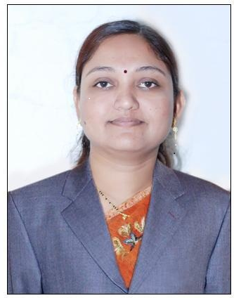
Designation | Assistant Professor
Date of barth | 07/01/1979
Qualification with Class/Grade | UG | PG | Ph.D.
Qualification with Class/Grade | BE (Elect); (2000) S.S.G.M.C.E.Shegaon  First class | ME (Power system); (2008), Govt. college of pune.  Higher second class | NA
Total Experience in Years | Teaching | Industry | Research
Total Experience in Years | 16 Years | Nil | Nil
Papers Published | National |  | International
Papers Published | 02 |  | 01
Papers Presented  in Conferences | National |  | International
Papers Presented  in Conferences | 01 |  | NA
PhD Guide? Give field & University | Field |  | University
PhD Guide? Give field & University | NO(NIL) |  | NIL
PhDs/ Projects Guided | PhDs |  | Project at Master Level
PhDs/ Projects Guided | NIL |  | NIL
Books Published/IPRs/Patents | Patents |  | Books
Books Published/IPRs/Patents | NIL |  | NIL
Professional Memberships | ISTE
Consultancy Activities | NIL
Awards | NIL
Grants fetched | NIL
Interaction with Professional Institutions | NIL

